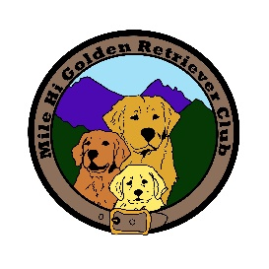
Mile-Hi Golden Retriever Club
2023 New Member Application
Name(s): ______________________________________________________________ Address: _______________________________________________________________ City: __________________________________ State: ______ Zip code: __________ Cell: _____________________________ Home: ______________________________ Email: ____________________________________________________________
Sign: ______________________________________ Date: ____________________
Your signature implies an agreement to abide by the code of ethics of the GRCA.

Please make your membership selection below:
Mail-In Prices: Family Membership ($30.00) ______ Individual Membership ($25.00) ______
PayPal Prices: Family Membership ($30.90) ______ Individual Membership ($25.75) ______

Please take a moment and share with us your knowledge and interests in MHGRC and Goldens.
How did you hear about MHGRC? _____________________________________________________
How long have you had Goldens? ______________________________________________________
Do you have friends in our club? _______________________________________________________
Anything else you would like to share? __________________________________________________
__________________________________________________________________________________

The club organizes many events throughout the year Membership meetings, Golden Retriever Specialty dog shows, all breed obedience trials and matches, agility trials hunt test, field training days, scent work trials, seminars and more. If you have a particular interest, please contact the event chair and learn how you can help before or during the activity.

Thank you for joining us!

Send this application to:
Pamela Biard, VP
MHGRC/Membership
275 Skylane Dr.
Erie, CO 80516
303-668-5572
Questions? Email Pam at pamelabk9@gmail.com

Application and Dues received/date: _________________________ (for MHGRC use only)

